Amaranth Growers Association

A Business Plan

**Prepared for Catholic Relief Services, Guatemala**

**2014 Notre Dame Business on the Frontlines Team**

Jessica Bonanno, M.B.A.

Kerri Citterbart Martin, Ph.D. Biology

Carolyn Edlebeck, M.A. Peace Studies

Matthew Kudija, M.B.A. & B.S. Engineering

David Paul, M.B.A.

Alan Sears, J.D.

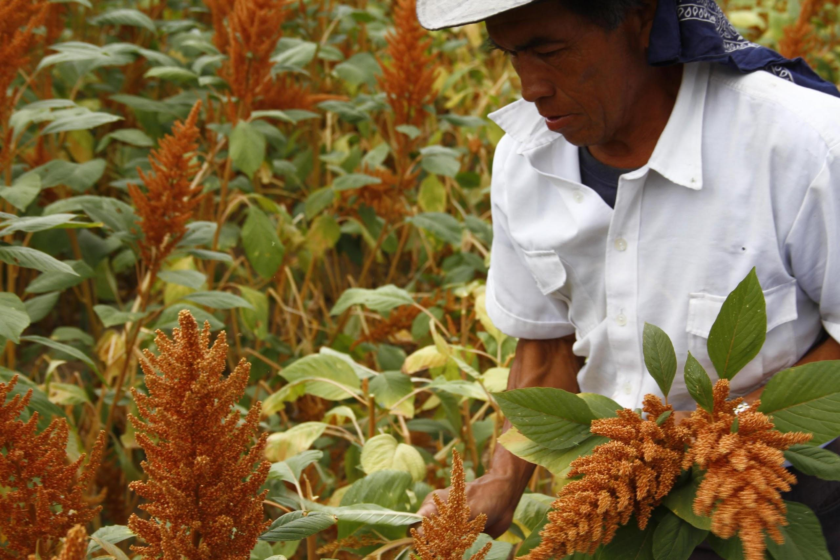

**Table of Contents**

I. INTRODUCTION

1.1 Dedication

1.2 Vision Statement

1.3 Mission Statement

1.4 Executive Summary

1.5 Assumptions

II. ABOUT AMARANTH

2.1 Overview

2.2 Nutritional Information

Grain Amaranth Nutrition Facts

Leaf Amaranth Nutrition Facts:

Amaranth In Nutritional Programming

Amaranth in the Western Highlands Food Desert

Plant vs. Animal Protein in Nutritional Programming

2.3 Cultivation

Amaranth Varieties:

The Growing Process

2.4 Consumption

Grain Amaranth

Amaranth Leaf

2.5 Other Uses for Amaranth

III. ASSOCIATIONS

3.1 Overview

3.2 The Model

3.3 Legal Formation

3.4 Associations and Livelihoods Programming

3.5 Operations

3.6 Management Team

3.7 Membership

IV. MARKET ANALYSIS

4.1 Market Overview

4.2 Market Trends & Demand Drivers

Gluten-Intolerance & Celiac Disease

Vegetarian/Vegan Lifestyle

Organic Movement

4.3 Market Metrics

Market Size

Rate of Growth

4.4 End-Consumer Segmentation

4.5 Competitive Landscape

4.6 Export Considerations

V. MARKETING & SALES

5.1 Marketing to Bulk Buyers (B2B)

5.2 Marketing to End-Users (B2C)

5.3 SALES

5.4 Growing the Market

VI. FINANCIAL ANALYSIS

6.1 Pricing Data

6.2 Startup Costs

6.3 Sample Profit & Loss Forecasts

Assumptions

VII. ADDITIONAL CONSIDERATIONS

7.1 Metrics

7.2 Risks

Supply Risks

Market Risks

7.2 Alternatives to the Association Model

Cooperative

Social Enterprise

Micro-Investments in Entrepreneurs

One Acre Fund Model

Alan’s citations on the quinoa bubbled:

Appendix

# I. INTRODUCTION

## 1.1 Dedication

Representatives from the University of Notre Dame graduate schools of Business, Law, Biology, and Peace Studies lovingly offer this business plan in support of the mission of Catholic Relief Services in Guatemala, for whose friendship and example of servant-leadership we are eternally grateful.

## 1.2 Vision Statement

Catholic Relief Services seeks to eradicate malnutrition and poverty in rural Guatemala, by investing in the development of nutrient-dense, economically viable agricultural value chains.

## 1.3 Mission Statement

The mission of this business plan is to encourage the development of farming associations to support rural farming families in Guatemala, with the twofold goals of improving nutrition by promoting amaranth consumption and increasing economic opportunity by facilitating the sale of surplus amaranth to end users.

## 1.4 Executive Summary

The nutritional and economic challenges of small-scale farming families in San Marcos and other rural regions of Guatemala are significant, with high levels of malnutrition resulting from both low incomes as well as limited access to healthy foods. Meanwhile, demand for niche health foods is growing among consumers in urban markets, driven by health concerns and lifestyle trends. In Guatemala City, there is a rising, unmet demand for gluten-free and vegan products, particularly grain amaranth.

To address rural malnutrition and satisfy urban demand for health food products, an intermediary organization is required to connect amaranth farmers to markets and provide technical training to farmers on production and consumption. Our analysis of the Guatemalan amaranth value-chain included interviews with multiple farmers, growing associations, retailers, consumers, exporters, and experts. Two key findings underscoring the importance of the intermediary role include:

1. Significant value creation & capture happen at the intermediary level of the amaranth value chain.
2. There is currently a gap at the intermediary/organizer level, which prevents small-scale amaranth farmers from accessing markets and results in unmet urban demand.

We believe this gap is a critical opportunity for CRS intervention.

Our research considered a variety of models which satisfy the intermediary role, including cooperatives, private enterprises, and other options. However, our analysis of several Guatemalan and Mexican amaranth growing associations revealed that the association model aligns strongly with CRS’ current approach to rural agricultural development programs, as outlined in the Pathway to Prosperity framework. In addition, the association model mitigates many of the chronic challenges that cause failure in other models. Based on this, we recommended that CRS consider supporting growing associations as a long-term, sustainable model for improving the wellbeing of small-scale farmers.

This business plan synthesizes our analysis and observation of best practices to provide general considerations and guidelines for developing such an association. While we use amaranth as the focus crop for this business plan, the best practices for an association discussed can be applied to most agricultural growing associations. Amaranth-specific aspects of this proposal are limited to agronomic and financial details.

## 1.5 Assumptions

We make several assumptions when constructing this business plan, informed by our field research.

* First, it is understood that a significant portion of the association startup costs, detailed in this report, are covered by grant money from a sponsoring NGO or other organization. While purely entrepreneurial models for filling this intermediary organization role exist, the association model typically requires some form of external assistance to cover initial costs.
* Secondly, all calculations in this report assume that association member-farmers consume about 30-40% of their amaranth production and sell only the remaining 60-70%. This or a similar benchmark is necessary to ensure that the tandem goals of improving family nutrition and economic health are both achieved.
* Finally, this proposal assumes that an organization, such as CRS partnered with Caritas, provides significant technical assistance to the association until it has reached the point of self-sustainability. Subsidization of technical assistance frees up association resources to serve rural farmers directly. For instance, certain agronomical research can be best conducted by a regional NGO and provided to several associations, rather than requiring that each association duplicate that work. Additional technical services that may be subsidized by CRS or a similar organization could include legal services, development of educational or marketing materials, and other technical activities which benefit from economies of scale.

# II. ABOUT AMARANTH

## 2.1 Overview

For thousands of years, Amaranth was the primary staple food of the indigenous peoples of the Central America. After the Spanish Conquistadors arrived in the Americas, their influence eliminated the use of Amaranth. In the 1970s, grain Amaranth was reintroduced to the world for food use and it has continued to spread throughout the world until today (Myers, 2002).

The amaranth seed can be consumed in three main forms: seed, flour, and popped. Since milling and popping the seed takes time and resources, flour and popped amaranth sells at a premium compared to the seed form.

Amaranth has two main benefits: First, it is high in nutrition, boasting a very high percentage of well-balanced protein (14%) that is high in lysine. Second, amaranth is relatively easy to grow. It is drought tolerant and can be grown in a variety of soil types (Myers 2002). These nutritive and growing features make amaranth a promising crop to help fight malnutrition.

## *2.2* Nutritional Information

Both the grain and leaves of the amaranth plant provide important nutrients. Relative to corn, the staple crop of Guatemala, amaranth outperforms in most important aspects of nutritional content, having a higher amount of protein, fiber, fat, calcium, iron, calories, folate, and zinc.

### Grain Amaranth Nutrition Facts

*Protein:* Amaranth has 14.5g of protein per 100g of grain, which is higher than most major grains such as wheat (10.7g per 100g), corn (9.4g per 100g), and brown rice (6.5g per 100g). Oats are the only major grain with higher protein content than amaranth (16.9g per 100g). Both amaranth and oats have more protein than an egg (12g per 100g).

*Lysine:* Amaranth also has high lysine content, which is an essential amino acid that the body cannot synthesize.

*Calcium:* Amaranth has 153mg of calcium in 100g of grain, which greatly exceeds the calcium of all other major grains (Oats - 54mg, Wheat - 34g, Corn- 7mg, Brown Rice - 3mg) (USDA).

*Iron and Zinc:* 100 grams of amaranth grain also contains 7.6 mg of Iron and 3.2 mg of Zinc. This iron content is higher than all other grains (Wheat-5.4mg, Oats-4.7mg, Brown Rice-4.23mg, Corn-2.7mg) and the zinc content is higher than both corn (2.2mg) and brown rice (1.1mg). (See Appendix)

### Leaf Amaranth Nutrition Facts:

In addition to its grain, the amaranth plant’s leaves, commonly referred to as “bledo”, in Guatemala, are also highly nutritious and contain more calcium, phosphorous, and vitamin C than both Swiss Chard and Spinach (USDA) (See Appendix).

### Amaranth In Nutritional Programming

Research has demonstrated that amaranth has been effective in addressing malnutrition. A study in Mexico showed that one spoonful (13 g) of amaranth protein concentrate per day reduced mild-moderate child malnutrition by 75%. Prior to the addition of amaranth to the diet, the numerous intervention attempts to reduction of malnutrition had not had a success rate over 8%. The researchers project that two spoonfuls (23 g) of amaranth protein concentrate per day could reduce severe malnutrition (Chavez 1997).

### Amaranth in the Western Highlands Food Desert

The Optifood analysis tool assessed the Western Highlands food basket and concluded that residents of that region had insufficient access to nutrients. The tool demonstrated that a combination of regionally available foods, including tortillas, potatoes, beans, eggs, green leafy vegetables, and a fortified cereal known as Incaparina, along with breast milk, could almost satisfy children’s nutrient needs, except for two key nutrients - iron and zinc, which are especially critical for children ages 6-8 months (Woldt and Bergeron 2013). Because amaranth is practical, nutrient-dense, and affordable, it may be able to help fill these nutrition gaps and make a nutritious diet more realistic for many with limited access to a variety of healthy foods.

### Plant vs. Animal Protein in Nutritional Programming

There is some debate over whether plant-based protein sources are sufficient as the foundation of malnutrition intervention programs. Despite the high nutrition content of grains like amaranth, the World Health Organization (WHO) currently recommends that animal protein be prioritized over plant protein, when fighting malnutrition. This recommendation is based, in large part, on the fact that animal proteins tend to be more easily digestible and higher in biological value than plant proteins (WHO 2003) and that plant-based diets tend to be low in iron, zinc and calcium (WHO 2005). Fortunately, amaranth comes very close to animal-based foods proteins in providing a nutrient-dense, balanced protein source.

*Protein, Digestibility, and Biological Value:* Animal protein sources usually contain all essential amino acids in similar proportions to those needed in human diets. Plant proteins can be substituted animal proteins but the correct balance is needed to ensure that all essential amino acids are contained in the diet.

Food digestibility refers to how easily a food is broken down and its nutrients absorbed. Biological value measures the proportion of a protein that will be incorporated into a person’s body by assessing how much of the protein will be used to synthesize other important proteins in cells. The biological value of a food is often limited by the amount of lysine it contains, lending credence to the WHO’s preference for animal proteins over grains, which are typically low in lysine.

Fortunately, amaranth is a grain that is extremely high in lysine. On average, grains have approximately 200mg/g N lysine (FAO) (See Appendix). By contrast, amaranth has approximately 370mg/g N lysine (Pisarikova et al 2005). This level of lysine is much closer to dairy products, such as milk (327-487mg/g N) or eggs (436mg/g N), compared to most grains or other non-legume vegetables (FAO) (See Appendix). With these high levels of lysine, the body can utilize the high levels of amaranth protein, just as it would an egg.

For comparative purposes, an egg has a biological value of 100%. Amaranth has a biological value of 90.4% when raw and 85.4% when popped (Pisarikova et al 2005). In comparison, milk has a biological value of 84%, beef 74.3%, wheat 64%, and corn 60% (FAO). The biological value of amaranth can actually increase when toasted at temperatures between 170°C - 190°C, but most popped amaranth is made by toasting is at temperatures higher than 190°C, causing its biological value to decrease, as described above (Pisarikova et al 2005).

*Nutrient Content:* Plant-based diets are usually low in iron, zinc and calcium (WHO 2005). But amaranth has higher iron, zinc and calcium content than egg. Per 100g, amaranth contains 7.6mg iron, 3.2mg zinc and 153mg calcium, while egg contains 1.2mg iron, 1.1mg zinc and 50mg calcium (USDA). Many other grains have comparable zinc and iron levels to amaranth or egg, but amaranth has an unusually high calcium content for a grain. This high nutrient content should make a diet that include amaranth much closer to a complete diet than than other plant-based diets.

One individual plant will never be able to compare to animal sources of protein, but because of its high biological value and high nutrition content, amaranth can be considered a protein source that is almost equal to most animal sources of protein.

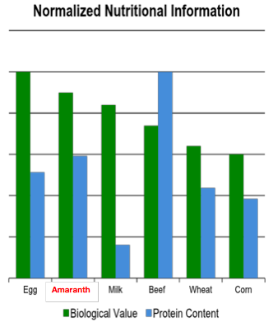

Figure 1. Nutrition information of amaranth and other major grains and animal protein sources. Amaranth has a higher biological value than other major grains and a biological value just below egg, the common food with the highest biological value. The protein content of amaranth is higher than the content of the comparable weight of an egg.

## 2.3 Cultivation

Amaranth is resilient, easy to grow, and can thrive in many types of environments. As a C4 plant, amaranth is drought-tolerant and can even be revived after wilting from lack of water. In Guatemala, amaranth can be grown during different months, depending on the region. Amaranth growing seasons vary by region but are generally comparable to the growing seasons of corn for the same region. In most areas of Guatemala, the amaranth growing season lasts 3-4 months, from planting to harvest. In other regions, the season is 8 months. Optimal timing can mitigate exposure to seasonal environmental risks, including frost or fungi.

### Amaranth Varieties:

While there are numerous species of amaranth plants, only three are used for grains – Amaranthus caudatus, Amaranthus cruentus, and Amaranthus hypochondriacus. Another variety of the amaranth plant, commonly referred to as *bledo* by Guatemalans, is *Amaranthus retroflexus*, a redroot amaranth which is frequently harvested for its leaves and consumed as a leaf vegetable. This leaf is popular because it grows without any cultivation, but this variety does not produce quality seeds for consumption. Unfortunately, seeds from these suboptimal Amaranthus retroflexus plants easily breed with those of higher-quality grain amaranth plants, which can lead to severely reduce nutritive benefits. The risk of cross-breeding must be considered during any amaranth seed selection or seed saving process.

### The Growing Process

*Sowing:* Amaranth plants are sown using two different techniques. The first option is to scatter the seed randomly or in pots, and then thin or replant once the plants have reached a certain height. According to the second technique, seeds are spaced evenly along a raised line.

Field Observations: In some regions, farmers planted amaranth side-by-side (*combinado*) with corn. In these cases, some farmers preferred to sow the plants in close proximity, so that the stronger corn stalks would protect the amaranth from wind, while others thought it was better to plant the crops further apart, so plants could grow taller, reaching more sun and helping to prevent fungus.

*Watering:* Though amaranth is drought-resistant, optimal amaranth cultivation requires more water than corn. For example, amaranth plants will wilt after 4 days without water, while corn can withstand 15-20 days before wilting.

Field Observations: We met with farmers who watered crops by hand, using jugs of well-drawn water as well as two farmers who utilized basic irrigation systems. The irrigation systems we observed, including a hose/pump system and the “mariposa” sprinkler system. All of these farms we visited were located relatively near water sources.

*Fertilization:* Amaranth fertilization practices vary widely, in Guatemala. In some regions, we observed that organic fertilizer made from decayed material from the previous harvest was the only fertilizer used. In other areas, store-bought chemical fertilizer was the main fertilizer applied. The amount of fertilizer also varied, depending on the region and the soil.

Field Observations: For example, members of the Kulbaalib Xechulub association used an average of four sacks of fertilizer (400 pounds) per cuerda (25x25).

*Harvesting:* The process of harvesting amaranth is slightly more labor-intensive than corn harvesting, requiring an average of five additional harvest days per querda. Most farmers harvest amaranth by hand, according to the following process:

1. Grain heads are snapped or cut from the stalk and collected in a pile.

(Use of a tarp helps collect any seeds which fall off).

1. Leaves are removed from the stalk. (These leaves can then be saved for organic fertilizer/compost or fed to livestock.)
2. The grain head is rubbed between hands or against a strainer to separate out the seeds.
3. Debris is captured, using a strainer, and the seeds collect in a basket beneath.
4. Further unwanted debris is separated from seeds using wind or a fan.
5. Seeds are dried in the sun for approximately 8 hours.

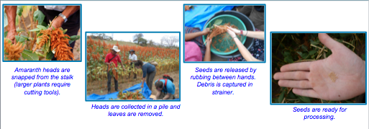

Field Observations: Although not a common practice, one farmer we interviewed described a harvesting process in which seeds were removed using a wood chipper-like machine, rather than by hand, before following the steps outlined above. However, it should be noted that this farmer grew grain heads which were approximately five times larger than the average we saw, in Guatemala.

*Storage:*

* Seed Storage: In general, amaranth seeds can last for quite a long time when properly stored, although seed longevity depends primarily on the quality of seed going in. Amaranth grain is usually stored in canvas sacks and can last from 8 months to one year, using this method. The seeds can be store for more time, if storage containers do not allow moisture to enter and are stored in a dark, cool place.

Pete Noll, Executive Director of the Mexican amaranth promoter, Puente a la Salud Comunitaria, reported that raw amaranth can be stored for 5 to 8 years. At Puente, the farmers store amaranth in standard grain 20 kg sacks, instead of 45 kg, as it allows women and older farmers to move them around. These sacks are stored on elevated plastic racks in a dry, relatively cool place, free of rodents or other pests.

One can assess whether the amaranth seed is in premium quality by whether the embryos are still red. Once the red color oxidizes to brown, the germination rate, nutrient content and flavor will diminish.

Field Observations: In Nebaj, farmers store the grain in their homes for several months, until they have accumulated enough to sell.

* Processed Amaranth Storage: Toasting amaranth inhibits enzyme activity, which can also extend shelf life. Shelf life for a popped product is quite long, for example, but only lasts about 9 months before the smell from oxidation causes an aromatic head that turns off most consumers, even though it's not necessarily rancid. Processed amaranth flour that is stored in a cool, dry place with mild or low humidity, can be stored for 12-18 months or more.

*Seed Selection & Recovery*: Careful seed recovery and conservation is vital to an the success of an amaranth project. Amaranth seed saving/selection in Guatemala is a sensitive process, due to the prevalence of wild Amaranthus retroflexus (bledo) plants, which can accidentally cross-breed with higher-quality varietals. Due to the technicality of seed selection, as well as differences in regional agronomic conditions, it is best for a qualified agronomist specialists to assess amaranth seed selection in detail before investing in an amaranth production project.

Field Observations: In order to determine which seed variety was best suited for the region, most associations we visited had members experiment for 2-3 years with different amaranth varieties. Farmers who tested different strains of amaranth would then supply seeds from higher-yield crops to the association, for preservation in a seed bank. These seeds were then sealed and stored for five years, as a germination test. Conserving a variety of strains acts as an important hedge for farmers against potential crop diseases, pests, or changes in weather patterns.

Associacion Qachuu Aloom emphasized the importance of local and native seeds to achieve their goal of food sovereignty. Five hundred families throughout their community had been trained to care for and conserve seeds. The association maintained several community seed banks and underground storage units, preserving seeds from over 50 plant varieties in natural clay jugs, modelled after those used in Mayan temples. This technique created a colder, low-humidity climate that extended the preservation period.

For more information on seed selection, refer to Dr. Riccardo Bressani’s articles in the resource section below.

## 2.4 Consumption

### Grain Amaranth

Grain amaranth can be prepared in a variety of ways, many of which resemble popular preparation techniques for corn. It can be eaten raw, toasted or popped, cooked like rice, or ground into flour.

*Popped Amaranth:* Amaranth can be popped in a popping machine, as is common in Mexico, but this method produces a less flavorful amaranth than toasting over a fire or stove, which is the most common method used in Guatemala. Popped amaranth, referred to as “Poporopo” in Guatemala, is eaten as a snack or used to make granola bars and treats. One popular treat is *Alegria*, a sweet, healthy snack common in Mexico, which combines amaranth, nuts, seeds, and sugar or honey. In our field tests, we noted that children and toddlers responded favorably to plain poporopo. Alegria received positive reviews from subjects of all ages.

*Amaranth Flour:* Amaranth flour (Harina, in Spanish) is made by grinding popped amaranth, using a machine or manual grindstone. The flour can be mixed into a number of corn-flour based Guatemalan recipes such as atole, pinol, tortillas, breads, and cakes. Due to differences in taste and texture, amaranth flour cannot completely replace corn flour as a recipe ingredient, without altering the end product. However, our subjects reported that an 80/20 mixture of corn/amaranth flour can be used to make tortillas, without affecting the taste or consistency. Amaranth flour was also used in *atol fresco*, a chilled drink mixture of amaranth, water, and sugar which is popular with children.

Since **atol** is a staple food for rural farming families with little or no disposable income, it is the easiest path of amaranth entry into the diet, followed by *Poporopo*. When introducing grain amaranth into the diet of consumers with more discretionary income, we found that the most frictionless point of introduction was through pre-prepared snack or workout foods such as Alegría, granola bars, granola, or health food drinks.

### Amaranth Leaf

An additional benefit of grain amaranth, which is attractive to subsistence farmers, is its dual use. While the amaranth plant is growing, its leaves can be removed for consumption and prepared in a number of *Bledo* recipes, including in caldos, in the local dish bosh-bol, and with egg as a type of patty. The amaranth leaf is most commonly consumed by the rural poor.

## 2.5 Other Uses for Amaranth

The vast majority of amaranth is consumed as food, but alternative uses have also been proposed. Amaranth oil has been used in dyes and is being investigated for its medicinal and cosmetic qualities. It is sometimes included as an ingredient in Shampoos and other beauty products. The technology to extract oil is expensive, but could become more affordable as demand increases.

# III. ASSOCIATIONS

## 3.1 Overview

A growing association is a membership-based, not-for-profit entity that exists to connect farmers with markets and provide other social services. An association is first and foremost a community organization: its roots are in one community and all of its activities are ordered toward improving the well-being of the members of that community. Specifically, this means focusing on improving both nutrition and livelihoods for member-families.

Growing associations come in many sizes and have diverse demographic composition, depending on the community and families involved. For example, over ten years Asociación Qachuu Aloom grew from five families in five communities to 400 members in 20 communities, with an 80% concentration of women. Centro Kulbaalib Xe'Chulub serves 100 members in 17 communities, with a 60-70% female composition.

## 3.2 The Model

As independent intermediaries, associations buy surplus crops from members and sell them to bulk buyers. Associations generate income from these sales as well as from member fees and grants and reinvest any profits in member services, such as education. The largest variable costs of a growing association are procurement, management salaries, and member training.

## 3.3 Legal Formation

We researched a variety of commercial entities in Guatemala (see also section 7.3) and concluded that

the asociación civil is the most desirable legal formation for a growers association, as described in this document. It is easier and less costly to create than alternatives. As a non-profit organization, the asociación civil is exempt from paying taxes and can subsidize fixed costs and management salaries through grants. Like cooperatives or other for-profit entities, they can still offer goods and services for sale, although they must reinvest any profits.

## 3.4 Associations and Livelihoods Programming

The association model aligns strongly with Catholic Relief Services’ approach to nutritional and livelihoods programs.

First, association missions are consistent with the first two strategic objectives of Catholic Relief Services’ Pathway to Prosperity Framework, assisting farmers in the recover and building stages.

1. Recover: Associations provide group organization, market-based access to seeds, and good production methods
2. Build: Associations assist with market planning, linking inputs, and maintaining effective seed systems

Second, a successful association must possess the 5 key skills for markets linkage, as defined by CRS: group management, financial management, natural resource management, marketing, and innovation. There is a clear opportunity for CRSs to give from its core competencies by supporting in skill development for association managers.

Third, we see overlap between the roles of the associations and the ECADI system and encourage the exploration of potential synergies with that program.

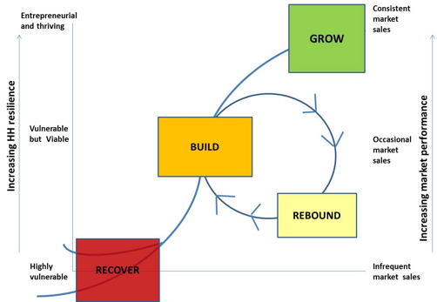

## 

## 3.5 Operations

Agricultural associations have a complex operational mandate. In addition to providing all of the typical business functions of an agricultural intermediary, they have additional responsibilities related to their role as a community development organization. The following is a summary of key association functions:

*Business Development:*  Associations possess the operational knowledge to connect farmers with markets. This includes sourcing potential customers, managing distribution logistics, negotiating the prices of inputs and finished goods, marketing their products, and developing competitive growth strategy. Association leaders must also develop and maintain relationships with funding sources, by engaging actively with banks or investors, public sector officials, the national and international NGO community, and any other external stakeholders. Finally, leaders must wisely balance commercial imperatives with mission goals, by developing sensitive policies related to internal governance and member services. All associations we visited had established fee structures, quotas, criteria for membership, and minimum consumption quotas to ensure that their member families’ nutritional needs are met.

*Financial Planning*: Association leaders require financial planning skills, including budgeting and cost management, forecasting, financial reporting, and maintaining an optimal capital structure.

*Quality Assurance & Seed Selection:* The association’s commercial success depends on its ability to supply quality products to buyers. Therefore, it is in the association’s interest to carefully manage supply through oversight of production inputs and ongoing stewardship of the seed supply. As referenced above, amaranth seed selection is a particularly sensitive process which requires expert oversight.

On the topic of seed selection, it is also worth noting that several amaranth growers associations we visited had strong personal beliefs about seeds, related to the heritage of amaranth cultivation among indigenous people, or to their desire to be independent from the Central Guatemalan government by maintaining a self-sustainable food supply. For these reason, amaranth associations like Qachuu Aloom maintain robust seed selection processes and storage banks.

*Product Processing/Packaging*: Associations must manage the processing of amaranth for sale in bulk or directly to consumers. This may include cleaning, storing, certifying, and directing any post-production/packaging activities. As output increases, associations can capture additional value by producing finished goods, such as popped amaranth or amaranth flour, in addition to supplying raw amaranth in bulk. Further value-added processes may also become feasible, over time. For example, were the association to diversify into other crops, such as honey, it could combine ingredients and produce packaged snacks, such as *Alegria*.

*Training:* The association plays a critical role in promoting best practices of agriculture and family nutrition by providing agronomical evaluation services and training, incentivizing crop diversification, and demonstrating food preparation techniques. According to practitioners, people are willing to grow and eat amaranth but *lasting* dietary change is the real challenge: some associations address this need by maintaining demonstration and test gardens, facilitating intercambios, or even hosting cooking contests. We noted strong synergies between an association’s educational and experimentation functions and the capacities currently being developed under the ECADI system, suggesting the potential for collaboration

Best practices: Asociacion Qachuu Aloom has developed a curriculum around amaranth cultivation, seed conservation, and processing and created a training team. Their training program is so successful that they receive many invitations to train other associations throughout Guatemala, and have completed training with two partners in Solola.

Centro Kulbaalib Xechulub emphasizes farmer to farmer information sharing, believing that it promotes the most relevant information, empowers farmers and strengthens communities.

*Membership Development:*  As membership grows, economies of scale will lower costs and enable the association to provide more services to the community and its members. Therefore, one of the primary functions of the association is to build trust and cultivate good relationships so that additional farmers are interested in joining. In rural areas, such as San Marcos, knowledge of the association will likely spread by word of mouth, making a strong reputation essential for success. The association also could reach new members by advertising free trainings or community events and/or having a presence in local markets and fairs.

*Community Support:* As role models and leaders, associations can perform valuable community development activities that strengthen relationships among neighbors and improve representation of the community’s interests in government. Associations we visited leveraged their role as community leaders to promote a sense of cultural identity, act as a central hub for community organization, pool capital to create savings and lending groups, and invest in general education for its members.

## 3.6 Management Team

Strong leadership is the single most important success factor for an agricultural association. As outlined above, association leaders have very diverse mandates requiring expertise in business, agriculture, and community/relationship development. The management team must be able to unite the community, oversee the delivery of technical and educational services, and connect farmers with markets, all while prioritizing family nutrition and economic health as the central goal.

The required number of leaders within an association depends on its age and maturity. Naturally, an association will start with one or two strong leaders and add staff as the association grows and matures. Some key roles to fill as the association grows include:

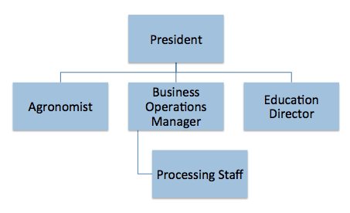

***President****:*  As the chief administrator, the association president oversees the overall operations of the association. This role is generally that of the founder and therefore the first filled. The president’s responsibilities include general management, internal policy, fundraising and communication with granting organizations, strategic planning, membership development, and staff development. The president must also embody and promote the soul of the organization by understanding what resonates with the community and creating a unifying goal around those ideas.

***Agronomist****:* Quality agricultural practices and seed stock are important for ensuring high crop yields. The agronomist oversees all technical aspects of the association. This includes researching and communicating region-specific agricultural best practices, maintaining an experimental and demonstration garden, and overseeing the association seed bank.

***Education Director****:* The Educational Director ensures that member-families have the best possible information about production, nutrition, and other topics important to the health of the community. Drawing on best practices from behavioral change models such as the Hearth Model and Positive Deviance Model, as well as field experience, this individual develops curriculum, coordinates and conducts training sessions with farmers, works with the agronomist or nutritional experts to develop educational materials, and oversees the recruitment and training of promoters.

***Business Operations Manager****:*  The Business Operations Manager oversees commercialization efforts including processing and packaging, distribution, marketing, supply chain relationship management, and and general financial decision making for the association. This can include participation in local, regional, or national events such as fairs, workshops, or conventions to sell seeds and for overall promotion.

Insert Chart of Mgmt Salary Range Here?

### 3.7 Membership

Associations maintain the integrity of their membership by vetting new members and requiring current members to meet ongoing minimum standards.

Best Practices: Asociaion Qachuu Aloom’s policies requires that all potential members:

* Share the mission/philosophy of the association
* Equally participate in activities
* Undergo a six month trial
* Be accepted by a vote of the Board of Directors
* Follow all association guidelines of fertilizer, seed storage, minimum consumption, etc.

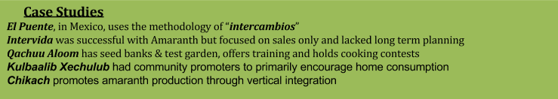

# IV. MARKET ANALYSIS

## 4.1 Market Overview

We focused our market research on the current suppliers and buyers of Guatemalan amaranth. Through this process, we identified unmet demand for bulk amaranth in Guatemala City, from producers of amaranth products and from niche health food stores which sell pre-packaged amaranth products to health-conscious consumers. Consumer demand is reportedly growing in urban areas, driven especially by interest in gluten-free products and vegan protein sources. Based on our research, we conclude that market is very attractive for Guatemalan amaranth producers.

A majority of amaranth sold in Guatemala City is imported from Mexico in popped form but, even with imports, bulk buyers cannot currently find all desired types and quality of amaranth, particularly raw seed. This indicates a strong market opportunity for Guatemalan amaranth producers.

Compared with mainstream crops, amaranth is relatively unknown in Guatemala. Although once a Central American staple crop, it is now consumed only by the rural farmers who grow it and by urban customers in the niche health food market. However, urban demand for amaranth is increasing even with little or no advertising, due primarily to changing health concerns and lifestyle trends, including rising incidences of gluten intolerance or celiac disease. Because amaranth is still largely unknown and is not sold in large supermarkets, there is also a large, untapped market opportunity among mainstream consumers, as the awareness of amaranth’s benefits grows and demand increases.

## 4.2 Market Trends & Demand Drivers

### Gluten-Intolerance & Celiac Disease

One reason for the increasing amaranth demand is a growing awareness of celiac disease, which is triggered by gluten, the protein found in wheat. Symptoms of gluten intolerance range from severe cramping to chronic fatigue and even organ disorders. Recent research in the Journal of the American Medical Association (Ludvigssons 2009) has found that the incidence of celiac disease has increased by a factor of four in the past three decades, yet its causes are unknown. According to Diane Walters, a spokeswoman for NuWorld Foods, “there is also a growing crossover market of health-conscious shoppers in search of the most nutritious grains” (Washington Post, 2006). Though Celiac disease necessitates a gluten-free lifestyle, the majority of gluten-free buying is a choice not a necessity.

### Vegetarian/Vegan Lifestyle

Vegetarian and Vegan diets require nutrient-dense protein sources. As described above, amaranth is a very useful substitute for meat, due in large part to its high lysine content. Vegetarians account for 5% of the population in the United States, and we assume these levels are similar, in Guatemala City. According to a Gallup Poll, these percentage appear to be holding fairly constant overtime, with little to no growth in the past decade. According to the owner of the Guatemalan health food shop, Artesano, about 25% of their customer base identifies as either Vegetarian or Vegan. If we find the number of 7th day adventists, that could be good info.

### Organic Movement

The demand for organic food in the United States has been increasing around 10% per year for the past few years and surpassed a total market of $30 billion dollars in 2012 (Organic Trade Association Press Release). Amaranth, though not always grown organically, tends to benefit from this growth in interest in non-GMO, organic superfoods. We expect the trends seen in the US to be a foreshadowing of trends in Guatemala City.

## 4.3 Market Metrics

### Market Size

Given that the urban middle class in the Guatemala City constitutes 35.4% (CentralAmericadata.com) of the population and that the core target market is among young adults (32.4% CIA World factbook), we estimate the amaranth market size in Guatemala City to be between 175,000 and 225,000 people, with many in the target market still unaware of amaranth.

Our estimate of current annual demand for amaranth in Guatemala is approximately 2,000 to 2,500 Quintales. Though exact numbers for Guatemala are not known, we have based these numbers on known figures from more developed North American Markets:

**Mexico** has been producing around 3,500 metric tonnes (~77,000 Quintales) annually. Mexico has had much more time to develop the market for grain amaranth, which is a key ingredient used in a popular snack bar known as *alegria*. The crop was introduced in Mexico much earlier than in Guatemala and has received government supporting for production and use in fighting malnutrition. After accounting for differences in size and the cultural differences in consumption, we arrive at the estimates above. (Pete Noll Executive Director of Amaranth Institute) (Resurge la Demand y Consuma de Amaranto en Mexico)

### Rate of Growth

In the **United States** we observe trends in the gluten-free market as a proxy for Guatemalan trends. Unlike corn, wheat, soy, rice or beans, amaranth is not deemed a commodity crop, but amaranth can be viewed as a competitor to other gluten-free products. The gluten-free market in the US has seen the demand for gluten free products increase over the past decade. Based off observed trends in the US gluten free market, we expect to see demand for amarnath in Guatemala to increase about 25% a year for the next 3 years and then stabilize at around 6% growth per year for the next 3 years. (Packaged Fact Gluten-Free Foods and Beverages in the U.S., 4th Edition)

*“Gluten-free products will go through a developmental/introductory stage, a rapid growth stage for three to five years, and then level off, and possibly decline, to their long-term level. We are a year or two into the rapid growth stage for gluten-free products. I think that ultimately this category will stabilize to a level consistent with demand associated with about 10 percent of the population.”* Mark Lang, food marketing professor, Saint Joseph’s University 2014

NuWorld Amaranth, a US based company and one of the main buyers of amaranth, reported a 300% increase in sales from 2003 to 2006 (Laux & Hoyle, 2006).

## 4.4 End-Consumer Segmentation

Currently, amaranth is a niche product with two primary end-consumer segments: rural farmers who grow it for home consumption and sell small quantities to their neighbors, and health food store customers in urban areas.

*Rural Consumers:* Our research indicates that the cultural connection to amaranth as the “Mayan super-food” is attractive to persons who identify as Mayan. This provides initial insight into potential marketing messages. Need more data here

*Urban:* The core demand for amaranth in Guatemala currently comes from the health food consumers, in Guatemala City. Health conscious city-dwellers have higher incomes, have active lifestyles, and are generally younger than the population average. According to Lula’s Oven, producers of amaranth snack foods, these customers want to eat nutritiously but do not want to compromise on taste. Many are interested in avoiding gluten or providing healthy snack foods for their children. Price is not especially important as long as it is similar to other gluten free products. They also seek convenient, ready-to-eat foods.

Health-conscious urban customers are an important customer segment to understand, from a marketing perspective. Many urban consumers have never heard of amaranth but may decide to purchase an amaranth product simply because it is labelled as gluten-free or as a superfood. A number of customers we interviewed mentioned that they stumbled across amaranth when looking for gluten-free foods. Many others were vegetarian or vegans looking for alternative protein sources, who were first introduced to amaranth while searching for sources of protein and complete amino acids.

## 4.5 Competitive Landscape

For the purposes of this report we consider the primary competition for Guatemalan amaranth to be Mexican amaranth, which appears to be dominating market share in Guatemala City. Health food stores such as Artesano currently source their popped amaranth from Mexico, as they are unable to obtain sufficient supply domestically. However, while this Mexican amaranth is cheaper than that sourced from Guatemala, it must be transported from the border and it is of relatively low quality. Currently, Mexican amaranth has a reputation for being unclean upon arrival, with dirt, harvesting debris, and insects which necessitates further processing and repackaging, adding to the total cost. This is an area of opportunity for farming associations that wish to compete with the incumbent supply chain. The resellers whom we spoke with would be willing to a pay a premium over current Mexican amaranth prices if they could find a reliable local source that provided clean, high quality amaranth.

Domestic competition comes primarily from other domestic amaranth associations. There are several associations utilizing amaranth, such as *Qachuu Aloom* in Rabinal, and *Kulb'aalib' Xe'chulub',* in Nebaj. For the foreseeable future, the currently unmet and rising demand will accommodate new associations as they are formed. There are a number of municipalities without any association that would benefit from the formation of new associations as proposed. Furthermore, existing associations demonstrate that there is significant room for improvement, including stronger connections with markets and transport networks.

## 4.6 Export Considerations

With the potential for amaranth to be the next superfood, the United States, Canada, and Western Europe represent good markets to export amaranth rich products. These markets have populations with higher disposable incomes and have a significant number health conscious consumers. But the story of global quinoa production highlights risks of amaranth export that must be considered.

But due to large quantities of amaranth being grown in India, China, Nepal, and Mexico, international prices are depressed, compared to Guatemalan prices. With time, economies of scale may make it more feasible for Guatemalan producers to enter the export market.

*A Cautionary Tale:* Quinoa is a gluten-free grain with all nine essential amino acids required for a balanced diet, which experienced explosive sales growth over the past decade, as illustrated below.[1] Unfortunately, prices for quinoa have risen as companies have converted large areas of land into quinoa fields. Now lower and middle class Bolivians can no longer consume the grain.[2] Organizations like Puente a la Salud Comunitaria are concerned that a robust export business will drive up the prices of Amaranth, making it economically infeasible for farmers to consume their own harvests, hence losing the health benefits of the crop.   
 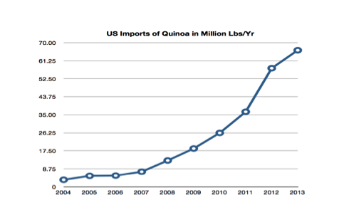

United States Quinoa Imports: <http://goo.gl/wEk5az>

Key technical differences between amaranth and quinoa make it difficult to assess the exact risk of amaranth prices following a similar fate. For example, quinoa only grows in a restricted geographical region so production has been unable to expand to meet the growing demand, leading to a sharp increases in price we need to cite this. By comparison, amaranth can be grown in a larger variety of regions, meaning that supply can more easily keep up with increasing demand and prices are more likely to remain stable.

On the other hand, the fact that amaranth has a wider growing region can also pose pricing risks. Unlike quinoa, amaranth can be produced in the United States. U.S. agriculture typically has considerable cost benefits from access to industrialized technology, more sophisticated markets, and government subsidies. Fortunately, large scale U.S. amarnath production in is unlikely, as demand is insufficient and amaranth production techniques are less amenable to industrial production (Personal Conversation, Cathy Bayliss). Therfore, downward pricing pressure from the U.S. is unlikely.

Before even considering exports, we recommend that an association first develop a strong national business, given the significant local growth opportunities and the association’s social goals. As their brand gains recognition in the local markets and production is able to scale to meet increasing demand, the potential to export can be assessed in by comparing the likely return on investment with the impact of such a project on the program’s initial goals. At a minimum, the association's minimum consumption policy will help ensure that farmers maintain access to the nutritional benefits of amaranth production.

If international export is pursued, obtaining “organic” certification from the Organic Crop Improvement Association (OCIA) or a similar organization would be advantageous, particularly in the United States and European markets. Until this point, there is no advantage in obtaining certification by an international body, apart from advertising purposes, nor is there a Guatemalan equivalent certification.

# V. MARKETING & SALES

## 5.1 Marketing to Bulk Buyers (B2B)

Associations’ primary marketing target will be retail sellers in Guatemala city (business-to- business marketing or B2B). Associations should cultivate relationships with producers of packaged amaranth food and with small retailers such as health food stores, yoga studios, and nutritionists. They should also seek to expand distribution by engaging in grocery store and restaurant trade shows. In terms of messaging, the association should emphasize its reliable supply, sustainable practices, and ability to meet quality specifications. Product emphasis should be on amaranth’s three core benefits as seen by the consumer: High nutrition (gluten free, vegan, superfood, etc), locally and organically grown in Guatemala, and the perceived mystic power of ancient grains.

## 5.2 Marketing to End-Users (B2C)

Most association amaranth will be sold in bulk to retailers as raw seed or in larger shipments of finished products. However, associations which sell directly to consumers via a storefront or local market may engage in a small amount of business to consumer marketing (B2C). Consumer marketing should be targeted at one of the two primary customer groups: higher income, health-conscious consumers or rural, low-income consumers on the other.

Marketing efforts directed at the health-conscious group should focus on its benefits as a gluten-free food with niche nutritional properties. This emphasizes how amaranth meets their unique needs and justifies the premium paid in health food stores.

Marketing efforts directed at rural consumers focuses on the exceptional nutritional properties of amaranth as compared with other options, and therefore the ways in which it can help build healthy families. Our research indicates that the cultural connection to amaranth as the “Mayan super-food” is attractive to persons who identify as Mayan. This provides initial insight into potential marketing messages

As is standard practice, any marketing strategy should be targeted and field tested with consumers before substantial investment is made. Ideally, a comprehensive marketing strategy will be managed by a dedicated sales and marketing staff member at the association, and will be intensely focused on the customer segments which exhibit the most opportunity for growth. This individual would develop the unique marketing messages for each customer segment, oversee the development of marketing materials, manage the association's website and other communications, and manage relationships with sales partners.

## 5.3 SALES

The association should develop a comprehensive sales strategy which is tailored to its community. Here we provide general guidelines for consideration.

Product diversification is important for the success of the association. After an initial start-up period, associations should begin offering basic processed amaranth such as poporopo and harina, in addition to raw crudo. As indicated in the financial analysis, processing provides an opportunity for significant value creation and capture in the amaranth value chain.

Popped amaranth is in greatest demand and is easy to produce without specialized equipment. This popped amaranth can be ground into flour or further processed to produce finished snacks such as Alegria. While processing is important, the association should also keep in mind that amaranth seed was often not available in stores in Guatemala City. If packaged directly, this requires little processing and could fill an unmet market need and provide higher margins than items that require additional processing. Overall, associations should focus on engaging in as much processing as is appropriate and achieving a balanced, diversified product mix.

As an association grows, awareness of the benefits of amaranth will increase in the surrounding community, increasing local market demand. A forward-thinking association should seek to emulate *Asociacion* *Qachuu Aloom*, which has created a local store in Rabinal, where it sell amaranth and other natural foods and artisan products to the surrounding community.

As supply reaches a large scale, the association could also choose to expand further up the value chain by selling directly to consumers. A first step would be to build out its transportation network to urban centers, followed by opening a retail store in Guatemala City. This would allow the association to capture additional value and exact closer control of its sales and distribution channels.

## 5.4 Growing the Market

Working with other amaranth industry participants to grow the total amaranth market is in the long-term interest of amaranth associations, provided that such investment has a clear likely return. Here we offer some marketing suggestions aimed at increasing total consumer demand.

The first strategy that amaranth industry partners must employ is to clearly position amaranth in the minds of the Guatemalan consumer through an information campaign that will: (a) promote awareness of the product, (b) strengthen mainstream Guatemalan’s perception of the nutritional benefits of amaranth, (c) create excitement about amaranth’s place in Central American heritage and the opportunities it currently creates for rural farming families. This emphasis on heritage and social impact will be attractive to the young, health-conscious sumer segment, who are both socially-concsious and trendsetters.The association or industry could promote this message through advertising, social media, government partnerships, or celebrity brand ambassadors.

After creating excitement and building knowledge about amaranth, the second part of our strategy is to spur the widespread adoption of amaranth as part of the Guatemalan diet. While this will be driven by the information that was disseminated during the information part of the campaign, there should be specific marketing activities aimed at triggering consumers to try the new products.The promotion for these products should occur at the same time as the information campaign to capitalize on the interest that is generated about amaranth as an health food. Product sampling is a low-cost and high-impact tactic that would compliment the information campaign. Incorporating amaranth in to school feeding programs and enlisting health care providers to promote amaranth by educating them about its nutritional benefits are also high-impact strategies.

# VI. FINANCIAL ANALYSIS

A basic financial analysis provides a guide for projecting association economic performance and making financial decisions. The analysis presented here should be viewed as a framework to be applied to a particular association, rather than a final product. Project-specific considerations including regional growing seasons, market trends, types of funding available, required start up costs depending on already available infrastructure, and regionally available talent pool will determine the particular economics of any given association.

## 6.1 Pricing Data

Aggregated price data from our March 2014 research is included below. This data includes current prices for the three primary finished amaranth products (popped amaranth, amaranth flour, and Alegria) and is divided between association sale prices (assn.) and retail sale prices (end). All price data is in Guatemalan Quetzales (GTQ). Also note that raw amaranth is sold by farmers for 8 GTQ/lb to 12 GTQ/lb.

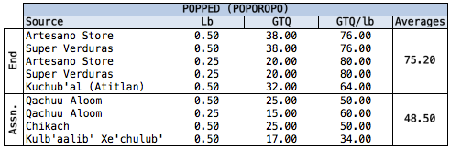

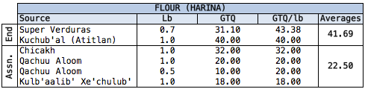

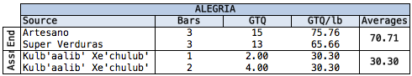

Aggregating this price data provides a view of the value added by each player in the amaranth value chain. It is readily apparent that the association adds and captures significant economic value by packaging and/or processing the raw amaranth bought from local farmers into flour, popped amaranth, and amaranth bars (alegria) for sale to retailers.

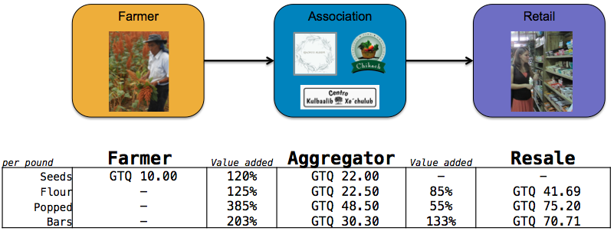

## 6.2 Startup Costs

Start-up costs can be broken into several categories, including infrastructure, processing equipment, incorporation costs, supplies, and other costs.

*Infrastructure*: Initial infrastructure costs will include the purchase of a small, centrally located plot of land and the construction, renovation, or leasing of of buildings. Association facilities we visited often included meeting areas for trainings, administrative offices, an area for cleaning and processing, a restroom (possibly utilizing fertilizer latrines), and two agricultural storage facilities--one for harvested grain, and another for a seed bank. Other facilities may be built as needed and could include a full-service kitchen or restaurant, a storefront, or a hostel for overnight visitors, volunteers, or eco-tourists.

*Processing Equipment*: At a minimum, associations require equipment to clean, package, and store their products. Additional post-processing equipment could enable the association to diversify beyond crude amaranth into higher value products. A stove or popping machine would be necessary to be able to make popped amaranth, which fetches a much higher price than crude amaranth. Making flour requires a stove as well as grinding equipment, or a mill.

*Incorporation Costs*: There would also be costs for the legal formation of the association. As discussed above, we recommend registering the association as a “asociación civil,” due to its ease of creation and tax exemption. The fees to register the association are varied and combine to an amount of approximately Q400.00 (however, with a large initial capital investment it could be a little more--there is a fee of Q1.50 for each Q1000.00 of initial capital invested). If a lawyer must be retained, this comes at an additional cost.

*Supplies & Other Costs:* In addition, the association would require the development of website, as well as the purchase of furniture, a computer, a printer, a credit-card processing machine, an initial stockpile of packaging supplies such as containers & custom product labelling, and miscellaneous office supplies (pens, paper and other small items, business cards for the leaders, etc).

As outlined below, we estimate the total start-up costs for forming an association to be within the range of 30,000 GTQ to 40,000 GTQ. It is important to consider that actual startup costs may vary widely, depending on regional price differences, the size of the community, availability of preexisting assets, and other factors, and should be evaluated for each association individually. We anticipate that this initial capital investment could be funded through grants or donations of money or physical assets.

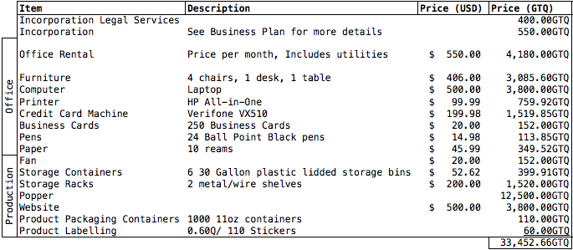

## 6.3 Sample Profit & Loss Forecasts

We have prepared a rough pro-forma income statement to provide a high-level view of operating revenues and expenses, for an association. For simplicity, we have modelled a single-crop association which sells only amaranth, however it is much more desirable that the association be diversified.

### Assumptions

As with any business plan, the output of our financial forecasts depend on the accuracy of our inputs, which vary by region and over time. Readers are cautioned to update these inputs at the time of project development. Our model is based on the following assumptions:

*Revenue:* The income statement assumes that raw amaranth is purchased by the association from the farmers, processed into flour, popped amaranth, and alegria bars, and sold to retailers according to the percentages listed. Sale prices are averages from the list presented in section 6.1. Additional revenue includes farmer membership fees, if applicable.

*Expenses:* Expenses are then itemized to arrive at the profit generated by the association (a negative number indicates that the association requires external grant support to subsidize operations). We include estimated costs for packing, transportation, training, etc. as estimates that require revision for a particular region or set of circumstances. Additionally, estimates for labor, building maintenance, utilities, and marketing expenses will vary widely between associations depending on their maturity and assets, and must be accounted for accordingly.

In addition to the example below, an excel template of this income statement is provided as a supplement to this document, as a framework with which to analyze detailed information about a particular association: <Income Statement Templates.xlsx>

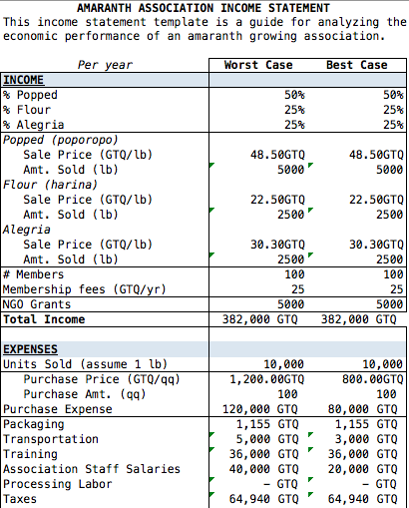

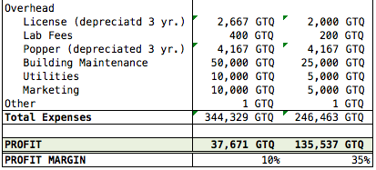

Starting with the baseline case, we project income, expenses, and profitability over a five year period. This assumes 3% inflation and 5% annual growth in the number of members and amount of amaranth sold, as well as the hiring of additional staff in year 3. This is an estimate and we recommend CRS use the Excel template spreadsheet to evaluate individual associations for analyze their projected financial performance.

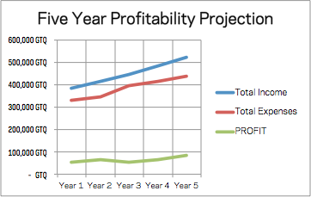

# VII. ADDITIONAL CONSIDERATIONS

## 7.1 Metrics

In order to gauge the success of this campaign, we have formulated the following metrics that can be used in its evaluation:

(1) Increase in profits and commensurate increase in worker salary

(2) Increase in awareness in amaranth properties

(3) Increase in retailer penetration across Mexico

(4) Increase in sales of amaranth products

(5) Increase in number of workers employed

(6) Increase in number of amaranth farmers supported

By evaluating these metrics and comparing results to comparable benchmarked data and previous time period’s performance, the success of the overall mission will be ascertained.

## 7.2 Risks

Agricultural associations are vulnerable to several supply chain and market risks, as summarized below. However, our preliminary research suggests that some forms of business insurance may be available to help mitigate these risks. Further research is needed to evaluate the availability and costs of these insurance products, in rural areas.

### Supply Risks

*Environmental Risks*: As a C4 crop, Amaranth is highly resilient to weather and climate variables, such as drought and temperature changes. However, before beginning an amaranth production project, it is important to conduct a region-specific feasibility analysis which includes appropriate consideration of environmental risks.

*Pests*: In the areas with 3 month growing seasons, a fungus can destroy the crop if the seeds are started too late during the wet season and grown too close together. Some farmers try to prevent this problem by planting corn, instead of amaranth, during the wet season. Others plant approximately a month before the wet season begins and replant or thin the crop to have greater spacing between plants. Other potential issues include the potential for stored grains to be eaten by pests and rodents and for birds to eat the grain as it is growing. Furthermore, one farmer mentioned having issues with the small black worm, *guisano nochero*, since it ate at the trunk of the plant if not looked after closely.

*Producer Risks*: This model assumes that labor is shared among a small set of family and/or community members. As such, production may be disrupted by illnesses, community emergencies, the availability of higher-paying employment opportunities, or any other human variable which could render one or more producers unable to work.

*Political Risks*: Any commercial activity is vulnerable to political conditions including war, redistributive land programs, political instability, changes in industry regulations or tax rates, and other uncontrollable circumstances.

*Natural Disasters*: Any commercial activity is vulnerable to natural disasters including earthquakes, hurricanes, tsunamis, drought, and others.

### Market Risks

New Entrant Risks: Because the amaranth market is so attractive, there is always a threat of entry by a new player (with substantial funding or venture backed) or an existing large scale agricultural producer.

*Demand Risks*: A critical assumption underlying this proposal is our expectation that demand for amaranth will continue to grow. However, health food trends come and go and any amaranth-based business is vulnerable to changes in consumer preferences that negatively impact demand.

*Price Risks*: As with any commodity, the ability to capture market premiums is eroded as supply is increased. Market prices of amaranth are subject to changes in supply and demand levels, both locally and internationally, and any significant increase in relative supply could adversely affect the profitability of this model *and* may make it unreasonable for farmers to consume their own product (see section 4.X)

## 7.2 Alternatives to the Association Model

As an intermediary, the association we have proposed fulfills a critical role by promoting improved nutrition and livelihoods for rural farmers. That said, there are other organizational models that could fill this role, each with its own set of benefits and challenges. Alternatives that CRS might consider supporting include cooperatives and other for-profit business models.

### Cooperative

One popular alternative legal formation is a cooperative (“cooperativa”). Cooperatives function similarly to an association and provide many of the same benefits to farmers, such as enabling economies of scale, increasing bargaining power, sharing costs of new technology, adding value to agricultural products, gaining access to new markets, and spreading around the risks associated with new enterprises. Like an association, a cooperative is centered around a social goal, but unlike an association, it can make a profit.

The key difference between a cooperative an association comes down to ownership: cooperatives are owned by their members, while associations are non-profit organizations which, by definition, exist without owners. Collective ownership may help strengthen community ties and can empower members-farmers. to have more input in organizational decision-making. However, this same ownership structure is more vulnerable to the free-rider problem than other models and its democratic decision making process can also decrease operational efficiency.

The process to create a cooperative is more detailed than what is required to form an association and involves a 15-step process. However, the cost to create the cooperative is only marginally more expensive than the cost of forming an association. The exact cost varies according to the initial capital investment and associated properties but should not exceed Q500.00

### Social Enterprise

A private business could function in essentially the same market capacity as an association, and serve a social goal. The primary differences would be the loss of tax exemption and the ability to make a profit.

There are a 5 types of “sociedad mercantiles” that could be formed: “sociedad colectiva,” “sociedad de comandita simple,” “sociedad de responsabilidad limitada,” “sociedad anónima,” and “sociedad en comandita por acciones.”

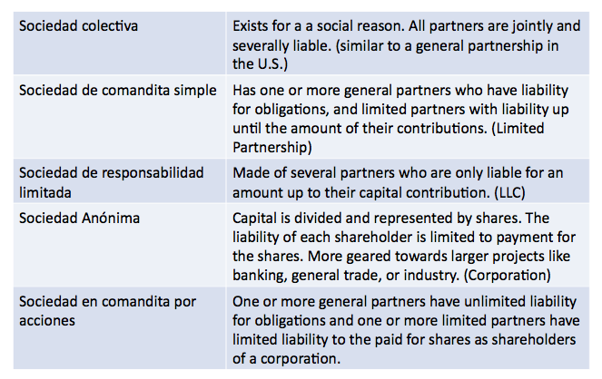

If this route were taken, we recommend one formation in particular, the “sociedad de responsabilidad limitada,” as there is a limit to liability. Under this formation, creditors would only be able to obtain redress from the capital investment in the organization and thus personal assets would not be subject to loss. The cost of registering a business is about Q550 if initial capital is less than Q300,000.00 or approximately Q750 if more (plus Q8.50 for each thousand of capital invested, which would be at least Q2,500.00).

### Micro-Investments in Entrepreneurs

Another model that could promote nutrition and connect farmers to markets is investing in entrepreneurs who are motivated to producing and selling amaranth at scale. Many in the development community believe that investing in private entrepreneurs is a better way to engender change, because the strategy leverages powerful economic incentives that may accelerate the go-to-market process. Similar to the Acumen-fund model, CRS or its partners could harness this motivation by identifying promising entrepreneurs and providing scholarships, business training, or direct debt and equity investment.

One important consideration that arises with relying on private enterprise to fill this intermediary role is ensuring that the entrepreneur is incentivized to support the nutritional and economic development set by CRS. Ideal entrepreneurs would have both business acumen as well as a concern for the mission of poverty alleviation in rural areas. The Acumen Fund accomplishes this through a clearly defined investment criteria:

1. GEOGRAPHY: Must be located in or have significant operation or impact in East Africa, West Africa, India, Pakistan or Latin America.

2. SECTORS: Must operate in one of Acumen Fund’s investment sectors of Agriculture, Energy, Education, Health, Housing, or Water

3. INVESTMENT SIZE: Must be seeking investment capital in the range of $0.25M-$3M, structured as either debt or equity.

4. STAGE: Must be an early-mid stage company that is in the process of scaling. Acumen Fund *rarely* invests in pure start-up companies.

5. POTENTIAL FOR SIGNIFICANT SOCIAL IMPACT: Must make a product or deliver a service that addresses a critical need for the poor in our sectors and geographic focus. These products or services need to be economically better or create greater social impact than what is currently available on the market or through charitable distribution channels.

6. POTENTIAL FOR FINANCIAL SUSTAINABILITY: Must have a clear business model that demonstrates the potential for financial sustainability within a five to seven year period; including the ability to cover operating expenses with operating revenues.

Case Study: Jan Carlos, A Model Entrepreneur

Our research included an interview with Juan Carlos, an entrepreneur in San Marcos who produces and sells amaranth. Juan Carlos is an entrepreneur who would be an ideal candidate to receive investment from CRS. He is an agricultural technician who works for Caritas, teaching crop production and commercialization to rural farmers. During his free time, he cultivates and sells niche crops, including amaranth. Juan Carlos began cultivating amaranth in 2003 and has now increased his business to include sell approximately 4 quintals of amaranth grain per year, some of which is sourced from another farmer. Through trial and error, he has optimized his production techniques. He discovered how to minimize the risk of contracting fungus by separating plants to ensure that leaves are not smothering each other at an early stage and has streamlined the harvesting process by grinding whole flower blooms mechanically and then using wind to blow away all the debris. These methods have increased his yield and production efficiency.

Juan Carlos has also used his entrepreneurial skills to deliver amaranth in a way that is enticing to potential buyers. He recognized that common methods of packaging amaranth are not conducive for long-term storage. The bags that are often used are not easily resealed and lead to seeds spilling after the first use. Juan Carlos found that an air-tight, resealable jar prevents his product from spilling and spoiling. He also found that his clients like to be able to see the amaranth before buying it, so he made sure that his jars were transparent. These customer-centered innovations have allowed him to successfully sell amaranth in San Marcos.

Juan Carlos dreams of using amaranth to help improve nutrition and incomes throughout the San Marcos area. He so believes in its nutritious quality that he ensures that he and his extended family consume 20% of his amaranth product. If he had the time and resources he would increase amount of amaranth he buys from additional farmers, make more finished goods out of amaranth, such as cookies, alegria, granola, and an amaranth nutrition extract, and then sell it in areas beyond San Marcos. An investment in an entrepreneur like Juan Carlos has the potential to improve the lives of hundreds of farmers and consumers, in Guatemala.

### One Acre Fund Model

CRS could support a model similar to the One Acre Fund, which works with smallholder farmers in East Africa. The One Acre Fund works with already existing farming groups, provides training and expertise to these groups in order to improve crop yields, and supplies seed and fertilizer on a credit basis.

The One Acre Fund aims to add value at each step of the value chain. Like numerous other models, the Fund helps connect farmers to markets and makes possible bulk-buying and other economies of scale. However, One Acre focuses primarily on increasing revenue by improving crop yield and much less on the family nutrition.

Given that one of the primary ways in which the Fund works is by supplying credit to farmers through the provision of fertilizer and seeds, it may be difficult to attract membership if a minimum consumption policy is in place, as proposed in the association business plan. A system such as this would prolong the debt of the farmers, by delaying the time it took to generate positive returns.

Works Cited:

Food and Agriculture Organization of the United Nations (FAO). The Amino Acid Content of Foods and Biological Data on Proteins, Nutritional Study #24. Rome (1970). <http://www.fao.org/docrep/005/ac854t/AC854T03.htm#chI.I.1->

Myers, R. L. 2002. Grain amaranth: a lost crop of the Americas. Alternative crop guide, Jefferson Institute.

Pisarikova, B. Kracmar, S., Herzig, I. 2005. Amino acid contents and biological value of protein in various amaranth species. Czech Journal of Animal Science 50 (4):169-174.

San Luis Potosi Health Services, 1997. Amaranth in Malnourishment Reduction.

Woldt, M and Bergeron, G., 2013. Optifood: A New Tool to Improve Diets and Prevent Child Malnutrition in Guatemala; USAID <http://blog.usaid.gov/2013/09/optifood-to-improve-diets-and-prevent-child-malnutrition-in-guatemala/>

USDA, [National Nutrient Database for Standard Reference: Release 26 <](http://www.nutrition.gov)http://ndb.nal.usda.gov/ndb/foods>

World Health Organization. Diet, Nutrition and the Prevention of Chronic Diseases. Report of a Joint WHO/FAO Expert Consultation. WHO Technical Report Series No. 916. Geneva, 2003.

World Health Organization. Guiding principles for feeding non-breastfed children 6-24 months of age. Geneva, 2005

Potentially Useful Resources:

Legal Formation

* Useful for all
  + <http://guatemala.eregulations.org/>
* Associations
  + <http://contapuntual.wordpress.com/2009/10/05/aspectos-que-deben-cumplir-las-asociaciones-civiles-de-guatemala-en-materia-administrativa-tributaria-laboral-y-fiscal/>
  + <http://www.slideshare.net/sdellabitta/organizacion-tipos>
  + <https://ocampoarch.wordpress.com/2006/08/07/asociaciones-y-sociedades-civiles/>
* Cooperatives
  + <http://www.aciamericas.coop/IMG/pdf/wcms_185442.pdf>
  + <https://contapuntual.wordpress.com/2011/04/13/caracteristicas-de-las-cooperativas-en-guatemala/>
* Businesses
  + <http://www.slideshare.net/Faitopedia123/sociedades-mercantiles-en-guatemala>

# Alan’s citations on the quinoa bubbled:

<http://www.nytimes.com/2011/03/20/world/americas/20bolivia.html?_r=0>

<http://www.mnn.com/your-home/organic-farming-gardening/stories/has-the-popularity-of-quinoa-hurt-the-people-who-grow-it>

<http://www.independent.co.uk/life-style/food-and-drink/features/quinoa-good-for-you--bad-for-bolivians-8675455.html>

<http://www.slate.com/articles/life/food/2013/01/quinoa_bad_for_bolivian_and_peruvian_farmers_ignore_the_media_hand_wringing.2.html>

[1] http://academic.mintel.com.proxy.library.nd.edu/display/654798/?highlight#hit1

[2]Howard, Brian. http://news.nationalgeographic.com/news/2013/08/130812-amaranth-oaxaca-mexico-obesity-puente-food/#.UypKTPmwKvc

# Appendix

Someone Needs to Make the List of Contacts in a Table for the Appendix

Partial List of Expert Sources:

